TCDS Smart Surveillance

Thief and crime detection system using CCTV from a legitimate distance from the crime scene by locating the suspect using the presence details provided by the victim.

With our thief capturing system we can easily find the suspect by using face detection, object detection, age, gender, body posture, and the speed of the suspect, and then if the details match with the details given by the victim then it will give the match found with the facts then it will provide the path details of the thieve within the range.

We have chosen a project based on significant usage in day-to-day fields as with the increase in the number of antisocial activities that have been taking place, security has been given utmost importance lately. Many organizations have installed CCTVs for constant monitoring of people and their interactions. Since constant monitoring of data by humans to judge if the events are abnormal is a near impossible task as it requires a workforce and their constant attention. This creates a need to automate the same. Also, there is a need to show in which frame and which parts of it contain the unusual activity which aids the faster judgment of that unusual activity being abnormal. Therefore, with the help of the created model we tried to put forward an attempt to provide a solution to such a problem as the model developed is a smart surveillance system that can detect unusual or abnormal activity automatically.

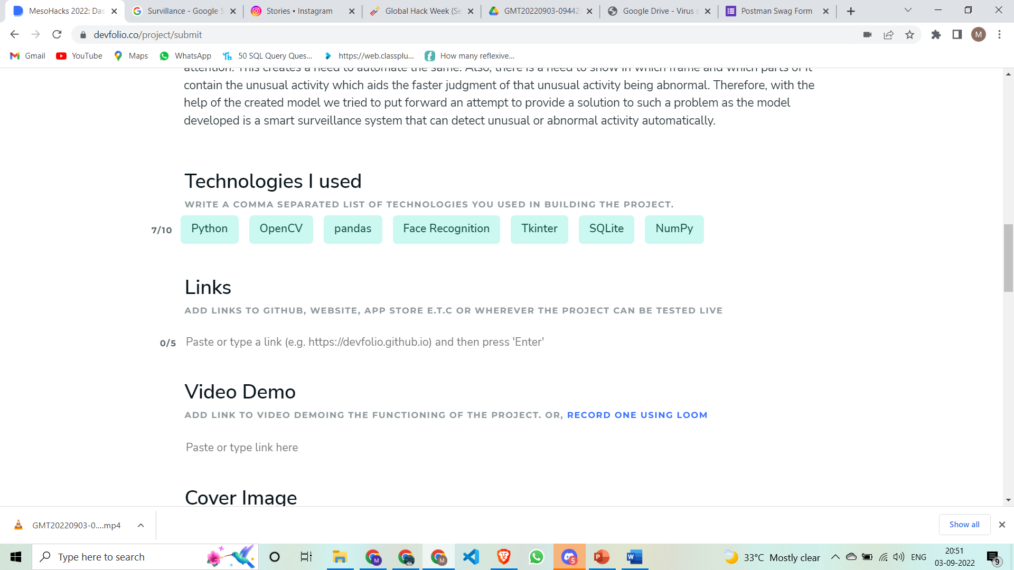

**About**

Python based project which deals with the extensive use of CCTV cameras